Exploratory Statistical Analysis of Extreme Rainfall Events Recorded by SNOTEL Stations 972 and 596 – City Creek Canyon, Utah
Kurt A. Fisher
July 23, 2019
Abstract: The maximum annual rainfall data at two Salt Lake City higher-altitude SNOTEL stations was used in support of making provisional estimates of 100-year rainfall exceedance levels. Two sets of 16 years of maximum annual rainfall data were fitted to the Gumbel distribution. The Louis Meadows SNOTEL Station (972) computed 100-year extreme rainfall exceedance level is 1.44 inches; the Lookout Peak SNOTEL Station (596) computed 100-year extreme rainfall exceedance level is 3.18 inches. These are provisional estimates because the 100-year level is extrapolated far outside the regression domain of 16 years. Two anomalous high readings in the Lookout Peak data are investigated as Gumbel regression influencers.
Gumbel method exceedance levels do not reveal how often exceedance rainfall will be nearly met within a 100-hundred year period. This question is investigated with a supplemental power law regression between precipitation and counts of hourly rainfall events (R²=0.99). In particular, the counts of 71 rare rainfall events ≥ 0.5 inches per hour over 16 years at two the SNOTEL sites are perfectly correlated (R²=1.0), even though the sites are separated by 3.25 miles and on only two dates do these high rainfalls occur at both sites on the same calendar day. This demonstrates two independent stochastic processes being driven by a third, hidden, deterministic causal model. Over 16 years, on only one date are their two consecutive hours of precipitation ≥ 0.5 inches per hour. For a range of high annual hourly precipitation events, e.g. 0.5 to 1.5, many more events occur than suggested by a once in 100-year maximum annual exceedance point estimate. We report a negative result: the maximum annual rainfall exceedance level does not appear to increase with altitude. Another 15 years of data collection will increase confidence in these provisional estimates and may reverse the conclusion that maximum exceedance rainfall does not increase with altitude.
Introduction
With respect to a personal project on the probability of cloudburst-fire floods in City Creek Canyon, quantification of extreme rainfall events at various altitudes using SNOTEL data from the Louis Meadows (972) and Lookout Peak (596) stations was undertaken.
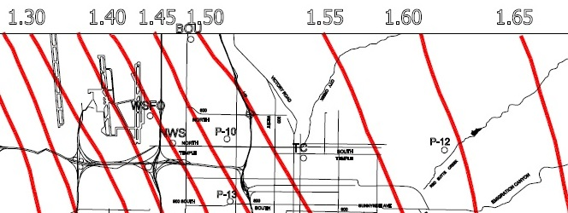
The Salt Lake County Flood Control Office has prepared duration-based 100 year rainfall prediction maps. For the east bench neighborhoods, the 30 minute duration map predicts a 100 year rainfall level of 1.20 inches and the one-hour duration predicted 100-year rainfall is about 1.5 inches. The Watershed Planning and Restoration Office extreme rain chart provides a point-estimate for a one-hundredth year 1-hour rainfall event of between 1.5 and 1.65 inches for a City Creek Canyon cloudburst: Empirical cloudburst flood events listed in Addenda A suggest this 100-year frequency estimate may be too low. During the 100 years between 1916 and 2016, there were three possible events of that magnitude in the 1.50-1.55 band – the 1918 West Capitol and the 1931 Beck Street cloudburst floods. In the 1.55-1.65 band, there were also three possible events between 1916 and 2016 – the 1916 Dry Fork flood, the 1945 Perry’s Hollow flood, and the July 28, 2017 City eastside flood.
Figure 1 - Salt Lake County. (August 1999). 100 Year Return Rainfall Map for 1 Hour Duration.
While the spatial location of cloudburst floods along the valley floor are random, Figure 1 shows that there is a progression of intensity from the valley floor to the Wasatch Front Mountains. Mountains make weather. Other metrological data from the National Oceanographic and Atmospheric Administration (NOAA) indicates that average annual precipitation in the Wasatch Front Mountains are higher than those on lower valley floors. That is why Salt Lake City can exist. We capture average high levels of snow and water during the winter season and store it to bridge water needs during hot, dry summers.
It is often said that “mountains make weather.” Higher elevations force clouds to rise and as a result, they release rain. It is reasonable to expect more cloudburst events of maximum annual rainfall at higher elevations such as the mid-City Creek Canyon’s Pleasant Valley or in the upper canyon between Grandeur Peak and Lookout Peak. The following hypothesis was formed: “Is the cloudburst rainfall event rate higher in City Creek Canyon at higher altitudes?
Methods
To test this commonplace, I obtained data for April 2003 to June 2019 from SNOTEL automated weather recording stations at Louis Meadows and Lookout Peak in City Creek Canyon which have been operated by the United States NRCS. Automated readings are taken every hour, the including temperature and one-hour duration accumulated rain and snowfall.
The elevation of the valley floor at 300 West and North Temple which appears at the Salt Lake County 100-year rainfall contour line of 1.5 inches is 4,280 feet. The Louis Meadows SNOTEL station about 8.25 northeast of this first valley floor station at an elevation of 6,700 feet; and the Lookout Peak SNOTEL station is about 3.25 miles up canyon from Louis Meadows at an elevation of 8,161 feet. Are there more 1.5 inch rainfall events than once every hundred-years at the higher stations?
The 288,413 raw hourly observations for these stations for the period April 1, 2003 to July 4 2019 were cleaned for instrumentation errors and station downtime. The stations recorded accumulated rainfall and snow since the instrument last reset in minimum increments of 0.1 inches. Hourly incremental values had to be derived by taking the difference of the current and preceding observation. Temperature was also reported hourly. Data was cleaned and recoded using attribute tags listed in Table 13 in Addendum “C”. Results are listed in Table 1. Exclusionary attribute tags were applied progressively. This means that if an hourly reading was excluded based on an earlier tag, e.g. “3”, that row would not be coded for exclusion based on a later attribute.
For the Louis Meadows station, 6.5% of raw observations were excluded as instrumentation errors, and, for the Lookout Peak station, 13.5% of raw observations were coded as instrumentation errors. After cleaning, data was recoded to change snow, snow-sleet, sleet, and evaporative events as “not a rainfall” event.
After cleaning and recoding, 15.4 years of valid hourly observations for the Louis Meadows station and 14.24 years of valid hourly observation data for the Lookout Peak station remained in 259,584 hourly observations (Table 1).
For those cleaned and recoded observations and the Louis Meadows station, 13,596 observations involved hourly rainfall precipitation in the range of 0.1 inches to 1.2 inches. For cleaned and recoded observations and the Lookout Peak station, 11,656 observations involved hourly rainfall precipitation in the range of 0.1 inches to 3.0 inches. With respect to the low percentage of total rainfall events (N=25,612, 9.9%) with precipitation greater than or equal to 0.1, recall that most of the annual precipitation at these mountain sites is in the form of snow. Snow-only events were recoded as “not rainfall” events with a rainfall precipitation equal to zero. Rainfall events involve summer season hourly changes of 0.1 inches and only rarely does more than 0.1 inches of rain fall in an hour. In contrast, winter snow can fall in feet over a few hours.

Table 1 - Characteristics of Data Cleaning and Recoding
 | Louis Meadows |  | Lookout Peak |  | Both
 | Count | Percent | Count | Percent | Totals | Percent
Total Observations | 144,237 | 100.0% | 144,176 | 100.0% | 288,413 | 100.0%
Instrument & Other Errors | 9,372 | 6.5% | 19,457 | 13.5% | 28,829 | 10.0%
Subtotal Cleaned and Recoded Observations | 134,865 | 93.5% | 124,719 | 86.5% | 259,584 | 90.0%
Zero rainfall events | 120,909 | 89.7% | 113,063 | 90.7% | 233,972 | 90.1%
Rainfall events => 0.1 | 13,956 | 10.3% | 11,656 | 9.3% | 25,612 | 9.9%
Checksum | 134,865 | 100.0% | 124,719 | 100.0% | 259,584 | 100.0%

Table 2 lists the observed annual maximum rainfall (X`) over 16 water seasons from 2003 to 2019. The observed cumulative distributions of the maximum rainfall for each year at the two stations are tabulated in Table 3 and are shown for each station in Figure 4 and in Figure 5. By inverting those figures, the cumulative annual maximum rainfall by increasing year of observation is shown in Figure 2 and Figure 3. Figure 2 and Figure 3 show the observed distribution for which modeling is sought.

Table 2 - Annual Maximum Rainfall (X`) for Louis Meadows and Lookout Peak SNOTEL Stations (2003-2019). Source: NRCS Report Generator 2.0.
Water Year |  | Louis Meadows | Lookout Peak
Start | End | X` | X`
2003 | 2004 | 0.4 | 0.3
2004 | 2005 | 0.9 | 0.5
2005 | 2006 | 1.1 | 2.1
2006 | 2007 | 0.5 | 3
2007 | 2008 | 0.9 | 1.3
2008 | 2009 | 0.4 | 0.5
2009 | 2010 | 0.7 | 0.4
2010 | 2011 | 0.5 | 0.9
2011 | 2012 | 0.6 | 1.1
2012 | 2013 | 0.8 | 0.5
2013 | 2014 | 0.6 | 0.6
2014 | 2015 | 0.6 | 1.1
2015 | 2016 | 0.8 | 0.5
2016 | 2017 | 0.6 | 0.5
2017 | 2018 | 0.7 | 0.6
2018 | 2019 | 1.2 | 0.5

[INTENTIONAL BLANK]

Table 3 - Cumulative Frequency of Annual Maximum Rainfall (X`) for Louis Meadows and Lookout Peak SNOTEL Stations (2003-2019). Source: Table 2
Louis Meadows |  | Lookout Peak
Years | Max Annual Rainfall | Years | Max Annual Rainfall
2 | 0.4 | 1 | 0.3
4 | 0.5 | 2 | 0.4
8 | 0.6 | 8 | 0.5
10 | 0.7 | 10 | 0.6
12 | 0.8 | 11 | 0.9
14 | 0.9 | 13 | 1.1
15 | 1.1 | 14 | 1.3
16 | 1.2 | 15 | 2.1
- | - | 16 | 3

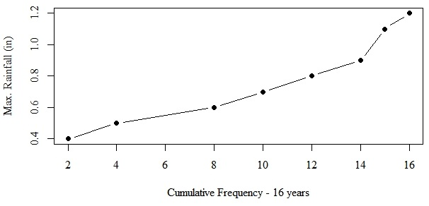
Figure 2 - Cumulative Maximum Rainfall (X`) by Observing Years for the Louis Meadows SNOTEL Station (2003-2019). Source: Inverted From of Figure 4.

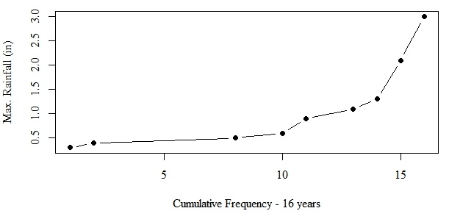
Figure 3 - Cumulative Maximum Rainfall (X`) by Observing Years for the Lookout Peak SNOTEL Station (2003-2019). Source: Inverted From of Figure 5.

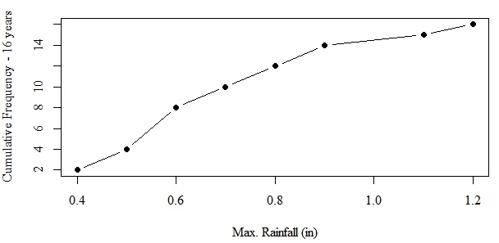
Figure 4 - Cumulative Frequency of Annual Maximum Rainfall (X`) for the Louis Meadows SNOTEL Station (2003-2019). Source:
[INTENTIONAL BLANK]

Table 3.

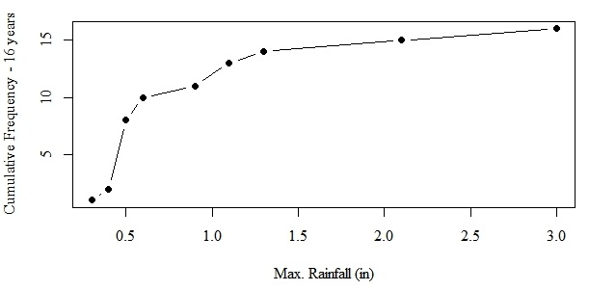
Figure 5 - Cumulative Frequency of Annual Maximum Rainfall (X`) for Lookout Peak SNOTEL Station (2003-2019). Source: Table 3.

The top two precipitation entries at the Lookout Peak station that do not data clean, re-code, or statistically test as outliers, are listed in Table 4. Much of the following analysis and discussion center around the inability to properly fit models to the Lookout Peak data. These two entries were initially suspected of causing poor model fits. Later analysis examines these readings as influencers during regression and concludes that they are not influencers.
Table 4 - Two Readings from the Lookout Peak Station that may be Potential Influencers
Date-Time | 4/2/2005 10:00 | 4/7/2006 12:00
Δ Precip (in) | 2.1 | 3
Air Temp (F) | 47 | 39
QC-Flag Air | V | V
Acc. Precipitation | 37 | 48.5
QC_Flag Precip. | V | V
Acc. Snow Depth | 104 | 117
QC_Flay Snow Depth | V | V
Snow Water Equivalent | 36.7 | 45.7
QC_Flag Water Equiv. | V | V

The hydrologist’s maximum exceedance rainfall over 100-years estimates a one-shot maximum level of rainfall; it does not inform as to how often high levels of rainfall may be approached or how often near-maximums occur. For example at Louis Meadows although the 100-year maximum event is 1.2 inches of rain, in one-half of 16 years, the maximum rainfall is 0.8 inches or higher This suggests that annually, there is high risk of some high rainfall events that may impact human safety or structures.
For Louis Meadows, Station 972, the observed frequencies of precipitation over 15.4 years are tabulated in Table 5 in Columns B and C. For Lookout Peak, Station 596, the observed frequencies of precipitation over 14.2 years are tabulated in Columns B and C of Table 6.

Table 5 – Louis Meadows SNOTEL Station – Frequency of Observed Hourly Rainfall Events and 16-Year Predicted Counts (N=134,865 observed Hours)
A | B | C | D
Over 15.39 observed years
Precipitation (in) | Count (observed) | Percent | Count (predicted)
0.0 | 120,909 | 89.652% | 120,952
0.1 | 12,793 | 9.486% | 11,690
0.2 | 913 | 0.677% | 2,980
0.3 | 155 | 0.115% | 1,130
0.4 | 57 | 0.042% | 532
0.5 | 19 | 0.014% | 288
0.6 | 8 | 0.006% | 171
0.7 | 3 | 0.002% | 109
0.8 | 4 | 0.003% | 73
0.9 | 2 | 0.001% | 51
1.1 | 1 | 0.001% | 28
1.2 | 1 | 0.001% | 21
1.3 |  |  | 17
1.5 |  |  | 11
Rare Event Counts
≥ 0.5 | 38
≥ 0.2 | 1163
Source: Author and NRCS SNOTEL Reporter 2.0. Notes: Italicized values are extrapolated beyond the range of the observations. Station 972 elevation - 6,700 ft. Notes: “Predicted Counts” from a power law model are discussed in the “Analysis” section, below.

[INTENTIONAL BLANK]

Table 6 – Lookout Peak SNOTEL Station – Frequency of Observed Hourly Rainfall Events and 16-Year Hourly Predicted Counts (N= 124,719 Observed hours)
A | B | C | D
Over 14.24 observed years
Precipitation (in) | Count (observed) | Percent | Count (predicted)
0.0 | 113,063 | 90.654% | 113,099
0.1 | 11,130 | 8.924% | 10,120
0.2 | 379 | 0.304% | 2,466
0.3 | 76 | 0.061% | 906
0.4 | 38 | 0.030% | 416
0.5 | 18 | 0.014% | 221
0.6 | 5 | 0.004% | 129
0.7 | 1 | 0.001% | 81
0.8 | 1 | 0.001% | 54
0.9 | 2 | 0.002% | 37
1.1 | 1 | 0.001% | 27
1.2 | 2 | 0.002% | 20
1.3 | 1 | 0.001% | 12
1.5 |  | 0.000% | 7
2.1 | 1 | 0.001% | 2
3.0 | 1 | 0.001% | 1
Rare Even Counts
≥ 0.5 | 33
≥ 0.2 | 526
Source: Author and NRCS SNOTEL Reporter 2.0. Notes: Italicized values are predicted within the range of the observations. Station 596; elevation – 8,161 ft. Notes: “Predicted Counts” from a power law model are discussed in the “Analysis” section, below.
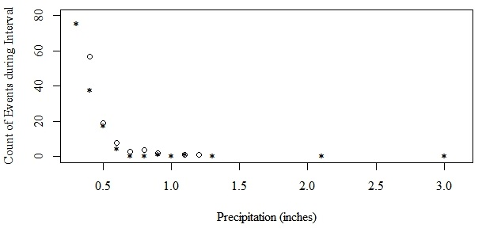
Figure 6 - Frequency of Counts of Hourly Rainfall ≥ 0.3 for SNOTEL Louis Meadows and Lookout Peak. (N=397). Source: Table 5 and Table 6. Circle - Louis Meadows, * = Lookout Peak.
The top 71 rare events for both stations are shown in Figure 6 and are listed in Table 7 where rainfall is ≥ 0.5 inches. Although the two sites are separated by 3.25 miles and 1,461 feet in elevation, they have nearly identical extreme rainfall count profiles. On only two of 36 event dates – June 8, 2006 and July 27, 2017 – does precipitation occur on the same calendar day. Only on July 8, 2015 does precipitation persist for two sequential hours at the same station. A third deterministic process is causing the same random effects at two different spatial locations.
Table 7 - The Top 72 Top Precipitation Events – Hourly Rainfall ≥ 0.5 inches at Louis Meadows and Lookout Peak by Date
Date | Station | Precip. (in) | Air Temp. (F) | Date | Station | Precip. (in) | Air Temp. (F)
7/17/2004 19:00 | 972 | 0.9 |  | 12/2/2012 20:00 | 972 | 0.8 | 35
8/18/2004 17:00 | 596 | 0.5 | 49 | 5/30/2013 9:00 | 596 | 0.5 | 42
4/2/2005 10:00 | 596 | 2.1 | 47 | 9/7/2013 16:00 | 972 | 0.5 | 55
8/2/2005 18:00 | 972 | 0.5 |  | 2/15/2014 10:00 | 596 | 0.6 | 44
10/3/2005 11:00 | 972 | 1.1 |  | 3/1/2014 14:00 | 972 | 0.6 | 39
2/27/2006 12:00 | 596 | 0.6 | 45 | 7/12/2014 8:00 | 596 | 0.8 | 66
3/21/2006 12:00 | 972 | 0.5 |  | 9/5/2014 1:00 | 596 | 1.1 | 47
4/7/2006 12:00 | 596 | 3 | 39 | 9/8/2014 16:00 | 596 | 0.7 | 50
6/8/2006 20:00 | 972 | 0.5 |  | 9/9/2014 6:00 | 596 | 0.5 | 47
6/8/2006 20:00 | 596 | 0.5 | 47 | 2/3/2015 15:00 | 972 | 0.6 | 45
11/21/2006 13:00 | 596 | 0.6 | 45 | 2/6/2015 19:00 | 596 | 0.6 | 46
4/8/2007 2:00 | 972 | 0.5 | 40 | 6/11/2015 13:00 | 596 | 0.5 | 48
5/4/2007 14:00 | 596 | 1.3 | 33 | 7/8/2015 21:00 | 972 | 0.8 | 51
7/25/2007 17:00 | 972 | 0.8 | 60 | 7/8/2015 22:00 | 972 | 0.5 | 51
2/27/2008 14:00 | 972 | 0.9 | 41 | 8/7/2015 18:00 | 596 | 0.5 | 50
7/15/2008 2:00 | 596 | 0.5 | 52 | 12/2/2015 14:00 | 596 | 0.5 | 33
6/2/2009 18:00 | 972 | 0.5 | 48 | 10/3/2016 12:00 | 972 | 0.5 | 37
6/7/2009 1:00 | 972 | 0.5 | 38 | 10/15/2016 22:00 | 972 | 0.6 | 60
7/2/2009 14:00 | 972 | 0.7 | 57 | 11/20/2016 7:00 | 596 | 0.5 | 43
2/25/2010 12:00 | 972 | 0.5 | 35 | 12/16/2016 9:00 | 972 | 0.5 | 39
5/29/2010 16:00 | 972 | 0.5 | 50 | 1/8/2017 18:00 | 596 | 0.5 | 38
6/12/2010 4:00 | 596 | 0.5 | 37 | 7/14/2017 17:00 | 596 | 0.5 | 56
12/2/2010 13:00 | 596 | 0.5 | 40 | 7/26/2017 2:00 | 972 | 0.5 | 55
12/8/2010 20:00 | 596 | 0.9 | 36 | 7/26/2017 3:00 | 596 | 0.6 | 52
4/5/2011 10:00 | 596 | 1.1 | 45 | 11/2/2017 5:00 | 972 | 0.7 | 35
4/11/2011 12:00 | 596 | 0.9 | 42 | 11/2/2017 18:00 | 972 | 0.6 | 51
6/19/2011 10:00 | 972 | 0.5 | 45 | 11/4/2017 9:00 | 972 | 0.5 | 43
7/24/2011 21:00 | 596 | 1 | 59 | 1/12/2018 10:00 | 972 | 0.5 | 36
8/1/2011 10:00 | 972 | 0.6 | 62 | 2/3/2018 6:00 | 972 | 0.5 | 39
8/20/2011 18:00 | 972 | 0.6 | 59 | 4/8/2018 1:00 | 596 | 0.5 | 34
10/16/2011 23:00 | 972 | 0.5 | 45 | 10/2/2018 20:00 | 596 | 0.5 | 48
11/12/2011 12:00 | 972 | 0.5 | 34 | 10/4/2018 23:00 | 972 | 0.8 | 42
4/26/2012 20:00 | 972 | 0.6 |  | 3/7/2019 13:00 | 972 | 1.2 | 42
5/10/2012 9:00 | 972 | 0.6 |  | 3/16/2019 14:00 | 596 | 0.5 | 39
12/1/2012 16:00 | 596 | 0.5 | 39 | 4/27/2019 14:00 | 596 | 0.5 | 49
 |  |  |  | 5/23/2019 1:00 | 972 | 0.7 | 38
Analysis and Results

Gumbel Extreme 100-Year Event Characterization after Hornberger
$$X^{*}=β-(α)ln\left[-ln⁡(1-\frac{1}{T_{return}}\right]$$
Equation 1 - Gumbel extreme value distribution
The generally accepted method by hydrologists to analyze extreme rainfall on 100-year intervals is by the Gumbel distribution method. The Gumbel distribution method involves determining the maximum rainfall event each year for a number of years. That data is used to estimate the parameters for the Gumbel cumulative distribution that predicts the likely interval of time in which a specified amount of rainfall will be exceeded. Gumbel distribution likelihood estimators for rainfall maximums per 100 years from Hornberger and NIST were used. The estimators for the maximum exceedance value X* from the maximum annual of each sampled year (X’) are α and β. Those parameters consist of:
$α= \frac{\sqrt{6}}{π}σ_{x'}$; σ_{Gumbel} - the Gumbel standard deviation – estimated from the standard deviation of X`.
$β=$ $EQ$$\overline{X'}$- 0.5572α; μ_{Gumbel} – estimated from the arithmetic mean of maximums.
And where the maximum rainfall exceedance value from the average return time is:
$$X^{*}=β-(α)ln\left[-ln⁡(1-\frac{1}{T_{return}})\right].$$
Parameters α and β were estimated (Table 8) and a fitted Gumbel distribution extrapolating the expected cumulative maximum rainfall events through 100 years was computed (Table 10) using R software code. The expected cumulative maximum rainfall events for the both stations are shown in Figure 9.

Table 8 - Estimated Parameters for Gumbel maximum event distribution
 | Louis Meadows | Lookout Peak
n | 16 | 16
μ | 0.71 | 0.9
σ | 0.232 | 0.723
μ _{Gumbel - β} | 0.6053 | 0.5637
σ _{Gumbel - α} | 0.1811 | 0.5859
X’_{100 yr} rain (in) | 1.44 | 3.18
Table 9 compares the observed and corresponding predicted cumulative annual precipitation levels for the two stations within the 16 year observing frame. In the context of a non-linear least square regression, these tests due not have the same weight and validity as in the linear and generalized multiple linear regression contexts. R² is only indicative for non-linear squares curve fitted. The χ2 value shows whether the observed and predicted curves are from the same statistical families, but for Lookout Peak, that 0.22 acceptance of the null hypothesis that the observed and predicted Gumbel distribution curves are from the same family may be a data artifact from the low fit evidenced by the low R². For Louis Meadows, the Kolmogorov-Smirnov test indicates that the observed and predicted curves are from the same Gumbel family of distributions. The KS test for Louis Meadows fails at 0.09.
Table 9 - Good-of-Fit Tests - Observed to Predicted - 16 Years of Observations
 | Cumulative max rain (in) over 16 years
 | 972 |  | 596
Years | Observed | Predicted | Observed | Predicted
1 | - | - | 0.3 | -
2 | 0.4 | 0.67 | 0.4 | 0.79
4 | 0.5 | 0.83 | - | -
8 | 0.6 | 0.98 | 0.5 | 1.72
10 | 0.7 | 1.01 | 0.6 | 1.85
11 | - | - | 0.9 | 1.91
12 | 0.8 | 1.04 | -
13 | - | - | 1.1 | 2.01
14 | 0.9 | 1.07 | 1.3 | 2.05
15 | 1.1 | 1.08 | 2.1 | 2.10
16 | 1.2 | 1.10 | 3 | 2.13
R² | 0.75 | - | 0.36 | -
χ² | 0.23 | - | 0.23 | -
KS test | 0.28 | - | 0.09 | -
This lack of goodness-of-fit for the Lookout Peak Station calls into question, on statistical grounds, extrapolating this fitted Gumbel distribution to out to 100-years. For the Lookout Station another 16 years of data will have to recorded in order to increase the confidence of that station’s forecasted 100-year maximum exceedance rainfall.
Table 10 – Maximum Predicted Exceedance Rainfall (inches) by 4 to 100 Year Intervals and Expected 100 Year Events Counts for Stations at Louis Meadows and Lookout Peak
Predicted Maximum exceedance
rainfall inches (X*)
Elevation (feet) |  | 6,100 | 8,161 | 4,280
Return time years | Expected Count per 100 years | Louis Meadows | Lookout Peak | 300 W. N. Temple
4 | 25 | 0.83 | 1.29
5 | 20 | 0.88 | 1.43
7.5 | 13 | 0.96 | 1.68
10 | 10 | 1.01 | 1.85
25 | 4 | 1.18 | 2.39
50 | 2 | 1.31 | 2.79
75 | 1 | 1.39 | 3.02
100 | 1 | 1.44 | 3.18 | 1.5
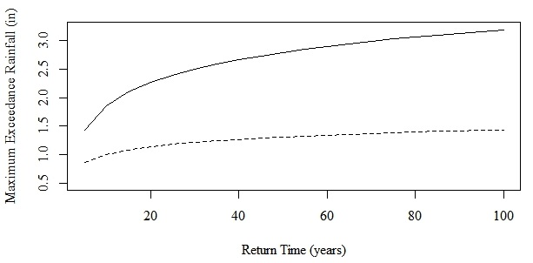
Source: Author and NRCS SNOTEL Reporter 2.0.
Figure 7 – Comparision of Predicted 100-year Maximum Exceedance Levels for Louis Meadows and Lookout Peak SNOTEL Stations, Years 0 to 100. Source: Table 8. Solid=Lookout Peak; Dashed = Louis Meadows.

[INTENTIONAL BLANK]
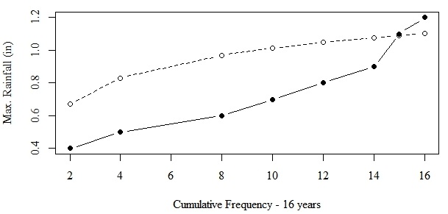
In conclusion, the Louis Meadows SNOTEL Station (972) computed 100-year extreme rainfall level is 1.44 inches. For the Lookout Peak Station (596) , the 100-year maximum exceedance rainfall was computed at 3.18 inches. Since both of these 100-year estimate values are far outside the domain of the 16 years of observations, they have low-confidence.
Figure 8 – Comparison of Gumbel Distribution Predicted to Observed Cumulative Annual Maximum Rainfall (in) for Louis Meadows for 16 years. Source: Table 9 and Table 10. Solid = Observed. Dashed = Predicted.

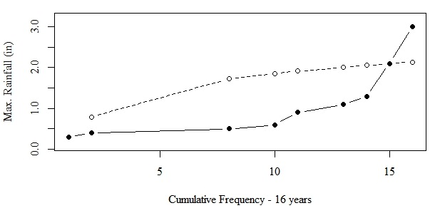
Figure 9 - Comparison of Gumbel Distribution Predicted to Observed Cumulative Annual Maximum Rainfall (in) for Lookout Peak for 16 years. Source: Table 9 and Table 10. Solid = Observed. Dashed = Predicted.
Influencer Analysis of Two Highest Lookout Peak Readings

Two potential outliers (2.1 and 3.0) at Lookout Peak might influence the 100-year Gumbel exceedance rainfall prediction. One statistical influence test to regress a model with and then without the potential influencer points. In order to investigate this possibility, the Gumbel distribution model was re-run for the Lookout Peak data, but with the 2.1 and 3.0 values censored out. The 100-year predicated rainfall remained declined to 3.0 inches with censoring. There were identical parameters and significance results for the Lookout Peak data.
The shape of the Lookout Peak maximum annual rainfall curve explains why the two points have relatively little influence on the model’s outcome. Figure 3 at page 6 above shows that most of the rise in Lookout Peak’s cumulative maximum annual rainfall occurs towards the end of 16 year period. This yields a steeper curve between years 10 to 16. Censoring the last two rainfall values of 2.1 and 3.0 does not change the observed slope between years 10 to 14. As a result, censoring the two top values did not change the parameters of the fitted curve for Lookout Peak. The 100-year maximum exceedance value decreased from 3.2 to 3.0. Compare Figure 3 for Lookout Peak with Figure 2 for Louis Meadows. The rise in the Louis Meadows cumulative maximum annual rainfall is slight and consistent over the observed interval. The result is that the 100-year maximum exceedance value remains near the maximum of the 16 year observed interval – at about 1.4 inches per hour. The two values of 2.1 and 3.0 should not be censored on the grounds of influence with respect to the Gumbel distribution.
The Likelihood of a Range of Precipitation Maximum Annual Events Over 100-years
Another measure of the magnitude-intensity characteristics of severe rainfall events is how often a range of severe rainfall events occur at various levels of precipitation. The 100-year exceedance level concerns magnitude, but a 100-year maximum exceedance point estimate tells us nothing about how many times over 100 years that lesser precipitation might occur that nearly equal the maximum. For example, it might be useful to know for Louis Meadows the number of times it would be expected that between one inch per hour and the exceedance level of 1.44 niches will be occur within a 100-year time frame. As seen in Table 5 and Table 6 when rainfall events are combined with site specific safety risk and structure engineering concerns on a less than 100-year time frame, safety risk events can frequently occur at less than the 100-year maximum. Evaluating this range of risks with a Gaussian distribution cannot be used because only average annual rainfall has a normal distribution; annual maximum levels do not.
It is mathematically possible to infer expected counts from the Gumbel-fitted maximum exceedance distribution (Table 8 and Table 9). The domain of Gumbel-fitted exceedance is the return time of a level of rainfall (T). The inverse of the return time implies an expected count (1/T) of the number of years over the 100 years that annual maximum rainfall will occur. Since the fitted distribution is continuous, Equation 1 at page 11 can be inverted.
$${{\frac{1}{T_{return}}=1- e}^{-e}}^{-(\frac{x-β}{α})}=F(a,b).$$
Equation 2 - Image-inverted form of Equation 1 - Gumbel maximum value survival function.
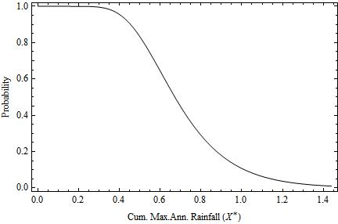
The right-hand side of Equation 2 is a Gumbel survival function for maximum annual rainfall across an interval (NIST, n. 6.). The Gumbel survival curve in Figure 10 shows how as the maximum annual rainfall increases, the probability of seeing that event within a 100-year time frame decreases.
Figure 10 - Survival Curve of Maximum Annual Precipitation over 100-years for Louis Meadows.
Applying the calculus anti-derivate interval rule that $\int_{a}^{b}{f}=F\left(b\right)-F(a)$, the probability that the number of years that a range of maximum annual precipitations will occur can be predicted. For example for Louis Meadows 100-year model (Table 1), for the maximum annual precipitation ranges between 1.0 inches and 1.44 inches,
$$F\left(1.0\right)-F\left(1.44\right)≃0.10,$$
or in 10 out of every 100 years, the maximum annual rainfall is expected to fall between 1.0 and 1.44 inches. For between 0.5 and 1.44 inches,
$$F\left(0.5\right)-F\left(1.44\right)≃0.82,$$
or in 82 out of 100 years, the maximum annual rainfall is fall expected to be between 0.5 and 1.44 inches.
However, this inverse function inherits the moderate-to-poor goodness-of-fit for original 100-year models (Table 9). The variation in the results of this method of predicting the likelihood of a range of precipitation events make it less useful as a predictive tool. In the next section, an alternative method – power law fitting - is used to address this question.

Power Law Fit of Count of Hourly Rainfall Events
$$y=Cx^{-α}$$
Equation 3 - Power law model
Another statistical approach to model the intensity of maximum events is to directly examine the total count of expected high, rare rainfall events over a defined interval. For Louis Meadows, a fitted power law density model (R²=0.99) appears in Column D of Table 5 on page 8, above. For the Lookout Peak Station, the same data and power law model are listed in Table 6 on page 9. The fitted parameters of each 16-year power law model are listed as follows. The fits have such high R² and low p-values because there are over 130,000 hourly observations for each station. Having a continuous distribution of counts implies that integration techniques can be used to answer “in-between” questions, such as “What is expected count of rain events between 1.0 and 1.4 inches?” over 16 years? The 16-year model regressions for each station are shown in Figure 11 and Figure 12.
Table 11 - Estimated Parameters and Goodness-of-fit for the Power Model of Hourly Rainfall (in).
Station | α | α se | p-value | C | C se | p-value | R² | N
972 | 3.371 | 0.093 | <000001 | 51.466 | 10.935 | <0.001 | 0.999 | 134,865
596 | 3.482 | 0.091 | <0.00001 | 37.252 | 7.784 | <0.0004 | 0.999 | 124,719

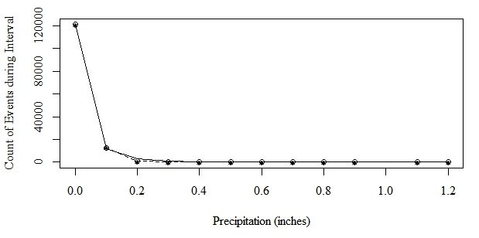
Figure 11- Counts of rainfall events from power law model for Louis Meadows over 16 years. * - Observed; Circles - Predicted. Source: Table 11.
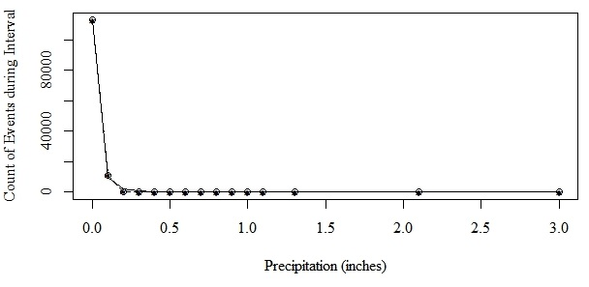
Figure 12 - Counts of rainfall events from power law model for Lookout Peak over 16 years. * - Observed; Circles - Predicted. Source: Table 11.
Calculus can again be used to predict the expected count of rainfall events over 16 years and for a range of precipitation events at the Louis Meadows station, e.g. – for the ranges 0.8 to 1.2 and 0.5 to 1.2 inches,
$$\int_{0.8}^{1.2}{51.444 x^{-3.371}≃23.}$$

$$\int_{0.5}^{1.2}{51.444 x^{-3.371}≃98.}$$

Similar predictions can be made for the Lookout Peak station,
$$\int_{0.5}^{1.2}{37.252 x^{-3.482}≃74.}$$
These predicted point estimates are much higher than the corresponding rainfall ranges are higher than the observed 16 year amounts (Table 5 and Table 6 at pages 8-9). This is attributable to the standard errors of the coefficients (Table 11), and that as the “tail” of rare events in a power law distribution is approached, the variance increases dramatically.
Advanced statistical techniques can be used to extrapolate these levels from 16 years to 100 years, by summing 6.25 (100/16) sets of power law random variables, but that is beyond the scope of this inquiry.
The main conclusion from power law analysis is considering a range of precipitation, there are many more occurrences of potential damage producing rainfall in City Creek Canyon than suggested by a point estimate of a 100-year Gumbel 100-year maximum exceedance rainfall of 1.5 inches from either the Salt Lake County 1-hour 100-year maximum exceedance rainfall map or from analysis of City Creek SNOTEL station data.
Discussion
Data cleaning and coding
There were two lessons-learned during this cleaning and recoding process. First, in order to preserve the integrity of the statistical process, raw– not NRCS cleaned – datasets should be used. Agency data error corrections do not fully code for all invalid data that should be excluded from a maximum rainfall exceedance analysis. Second, Excel was used for the cleaning and coding process. Stata should have been used because it better maintains a permanent traceable record of the data cleaning and recoding process. The final cleaned and recoded dataset is not attached due to size, but is available on request.
Does the Rate of Maximum Annual Rainfall Increase with Altitude?
A complete Gumbel distribution for valley floor extreme rainfall exceedance levels prepared by Salt Lake County is not available. Single point estimates of the maximum annual rainfall over a 1 hour period per 100 years suggests that X*_{100-years} increases with altitude.
 |  | Sign
 |  | Magnitude | Intensity
Station | Elevation (ft) | Gumbel (in-_{100yrs}) | Observed Events ≥ 0.5 in for 16 years
300 West N. Temple | 4,280 | 1.50 | Unknown
Louis Meadows | 6,700 | 1.44 | 38
Lookout Peak | 8,160 | 3.18 | 33
Louis Meadows has a lower predicted 100-year exceedance rainfall than the lower 300 West N. Temple station, but the Lookout Peak 100-year exceedance rainfall is higher than either Louis Meadows or North Temple. This is attributed to the physical setting. The Louis Meadows station is set in a deep canyon between Grandeur Peak to the north and Little Black Mountain to the south. The topography may be altering weather patterns. Conversely, the Lookout Peak station is located on an unobscured mountain ridgeline.
The difference between the observed count of rainfall events greater than or equal to 0.5 inches over 16 years was not significant between at the Louis Peak station as compared to the higher Lookout Peak station (38-33=3).
As discussed above, these estimates are based on extrapolating 16 years of observations outside the observed interval to 100-years. That process inherently reduces confidence in these predicted values, and these results should be considered provisional.
Overall the weight of signs, given the low confidence in extrapolating 16 years of data to 100 years, does not support the hypotheses that severe rainfall event increase with elevation.
Conclusion
In conclusion, based on 14 to 15 years of available cleaned SNOTEL data, severe rainfall events at these three stations most probably do not increase with elevation. Low-confidence point estimates for maximum annual rainfall 100-year exceedance ( X*_{100-years} ) are reported. Based on power law analysis considering a range of precipitation, considering a range of precipitation, there are many more occurrences of potential damage producing rainfall than suggested by a point estimate of the corresponding 100-year Gumbel 100-year maximum exceedance rainfall.
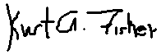
Suggested future work would be to expand data analysis of rare rainfall events at mountainous SNOTEL stations in an increasing radius around City Creek in order to determine if the high correlation of precipitation to counts in the rare event tail of power law distributions is a general result. An analysis of 1-hour precipitation events during the same 16 year time interval might be performed using University of Utah or Salt Lake International Airport station data on MesoWest in order to further investigate whether there is in fact a relationship between altitude maximum rainfall exceedance levels over 100-years and altitude.
Kurt A. Fisher

Addendum A
Key Historical Salt Lake City Creek Floods and Northern Utah Cloudburst Flooding Documents, Research and Academic Articles
Excerpts from SLC DPU GRAMA production to K. Fisher, June 13, 2019 (url: http://fisherka.csolutionshosting.net/misc/FourthAveWell/20190617ExcerptsfromDPUProductionre4thAveWell.pdf ).
As a result of the 1983 state-wide floods, the DPU’s predecessor spent about $1,000,000 repairing flood damage to roads from North Temple and State Street north to Memory Grove. The City replaced 1,040 feet of 6” inch pipeline excavated and damaged by flood waters between 4th Avenue and Memory Grove, 18 subsurface sewer and water connections in the area were destroyed, and the foundations of the old Brick Tank house north of Memory Grove were undermined.

Nicoli, K. and Lundeen, Z. J., University of Utah. (2016). A case study: geomorphic effects of the 2009 Big Pole fire, Skull Valley, Utah (Vignettes: Key Concepts in Geomorphology). Northfield, Minnesota. (url: http://serc.carleton.edu/47063 ).
A recent example of the effects of cloudburst flooding in northern Utah. In a large Skull Valley canyon fire covering about 41,000 acres. Such fires decrease soil permeability by 9 to 100 times. See also Craddock, below. During subsequent heavy rains in Skull Valley, large sheet flows occurred and craved 1 meter deep rills in the alluvium. Historically, a similar incident occurred a Dry Creek Canyon. In 1915, there was a large 4 square mile fire in the Canyon that spread over the Salt Lake City Salient southern city-facing hillside. See Salt Lake Telegram and Tribune, 1915, below. Woolley records that on July 25, 1916, a Dry Creek Canyon cloudburst sent a 4 to 10 foot wall of water down City Creek and into city, along with mud, boulders and cattle (below, Salt Lake Tribune July 25, 1916).

Wirth, Craig (KUTV News). May 12, 2014. Remembering the flood of '83. KUTV News. At min. 1:35. (url: https://www.abc4.com/wirth/wirth-watching-remembering-the-salt-lake-city-flood-of-83/204262974 )

Salt Lake Tribune, and Smart, C. (2011, Apr 29). River on State Street unlikely in 2011, official says. Salt Lake City Tribune. Salt Lake City, Utah. ProQuest No. 864039697. (Retrospective article in which Salt Lake Councilperson describes sandbagging efforts to control 1952 flood; available through Proquest (https://www.proquest.com/ ) or copy on file with this author).

Honker, A. M. (1999). “Been Grazed Almost to Extinction”: The Environment, Human Action, and Utah Flooding, 1900-1940. Utah Historical Quarterly, 76(1), 23–47 (url: http://heritage.utah.gov/history/quarterly ) (Includes review and photographs of Salt Lake City Creek flooding, in particular, in 1909. Overviews high-snow melt verses cloudburst flooding in northern Utah).

Salt Lake Tribune, June 3, 1983 and July 22, 1983. Reproduced in Salt Tribune. 1983. Spirit of Survival: Utah Floods of 1983 (Available at Reference Desk, Main Branch, Salt Lake City Public Library and Special Collections, Marriott Library, University of Utah, Call No. F830 .S657).

Boyce, R. R. (1958). A historical geography of Salt Lake City, Utah. Thesis. Masters. Department of Geography, University of Utah at 41 re 1876). (On file at Special Collections, Marriott Library, University of Utah; copy in author’s possession).

Salt Lake Tribune. April 30, 1952 (Available through https://go.newspapers.com/, re: floods of 1952).

Woolley, R. R. (1946). Cloudburst Floods in Utah: 1850-1938. Washington, D.C. at 96-120 (url: http://pubs.er.usgs.gov/publication/wsp994 )
Woolley listed numerous cloudbursts floods that have come across the Avenues District and from City Creek and across the proposed Well site and into the downtown: (Woolley 1946). Summer cloudburst floods included: June 13th, 1854 (city streets flooded), September 11th, 1864 (heavy flooding of North Temple from City Creek), August 25th, 1872 (downtown flooded), July 23rd, 1874 (downtown flooded from City Creek), August 1st, 1874 (Lindsey Gardens areas flooded as in 1945), August 8th, 1884 (North Temple flooded from City Creek), July 26th, 1893 (cloudburst flooded basements in city), July 19th, 1912 (1 inch fell in 1 hour filled South Temple with sand and mud from above), July 25th, 1916 (cloudburst sent a 10 foot wall of water into city along with mud, boulders and cattle), July 30th, 1930 (cloudburst over Emigration, Red Butte, and Parley's Canyons washed out highway north of Salt Lake and washed away three homes with damages of 500,000 USD), and August 13th, 1931 (four to 12 inches of water swept through streets and 12 feet of debris washed over road near Beck Hot Springs).

Craddock, G. W. (1946). The Salt Lake City Flood, 1945. Proceedings of the Utah Academy of Sciences, Arts and Letters, 23, 51–61. (On file with the Special Collections, Marriott Library, University of Utah; copy attached).

Salt Lake Telegram, August 20 and 27, 1945 (Available through https://go.newspapers.com/; copy in author’s possession).

Salt Lake Telegram, August 1, 1944. “S.L. Fire Burns Grass, Brush.” This fire potentially led to the Aug. 1945 Perry’s Hollow flood per Craddock (1946) (url: https://newspapers.lib.utah.edu/ark:/87278/s6j97frg/17144631 ).

Utah Flood Commission. (1931). Torrential floods in Northern Utah, 1930. Logan: Agricultural Experiment Station, Utah State Agricultural College. On file at Special Collections, Marriott Library, University of Utah. (url:.http://www.lib.utah.edu ).
Salt Lake Telegram. August 14, 1931. Flood Traps Car on Highway. (A cloudburst flood buried cars on highway to the north of Salt Lake City).(url: https://newspapers.lib.utah.edu/ark:/87278/s6cr728k ).
Salt Lake Telegram. Sept. 24, 1918. Property Damaged by Big Cloudburst. (A cloudburst flood swept down West Capitol Hill and buried properties at 200 West in up to 1 foot of mud). (url: https://newspapers.lib.utah.edu/ark:/87278/s6d80jz5 ).
Salt Lake Tribune. July 25, 1916. Cloudburst Kills Cattle in Canyon. (url: https://newspapers.lib.utah.edu/ark:/87278/s6j10wfd )
“A cloudburst breaking in Dry canyon during the electrical storm of yesterday emerged from the ravine a solid ten-foot wall of rushing water, carrying with it eight head of cattle and rocks weighing from 1000 to 1500 pounds, swirling them along as lightly as feathers. Following the course of the old waterway, the waters rushed through Popperton place, down Second and Third Avenues, turning on Ninth East to the Second South conduit before the force of the flood was spent. In the residence district of Popperton place and the avenues the telephone poles showed that the water mark to have been four feet."
Salt Lake Tribune. August 6, 1915. City’s Watershed Suffers from Fire. (url: https://newspapers.lib.utah.edu/ark:/87278/s6tf17rk/14627562 )
Salt Lake Telegram. August 5, 1915. Big Damage Caused by Brush Fire in City Creek. (url: https://newspapers.lib.utah.edu/ark:/87278/s6km0kdd/19586313 , re: 4 square mile brush fire in City Creek Canyon that crossed city-side ridgeline).
Salt Lake Telegram, June 19th, 1903. Salt Lake City in Path of Cloudburst, Should It Break in City Creek. (url: https://newspapers.lib.utah.edu/ar/87278/s6ck2gdq )

Addendum B
Table 12 - Four Cloudburst Floods Along the Salt Lake City Salient Since 1900. Source: Addenda “A”
Flood Date | Flood Location | Flood Description | Related Fire Date | Related fire location | Description
Sept. 25, 1916 | Dry Fork Canyon to 2nd Ave and 9th East | “Solid ten-foot wall of water rushing water . . .” | Aug. and Nov. 1915 | Dry Fork to Upper City Creek; Lower City Creek  4 to 7 sq. miles burned | In Aug. “four miles of east side of Canyon burned.” In Nov., fire spread from Dry Fork to upper City Creek.
Sept. 24, 1918 | West Capitol Hill to 200 West | Up to 1 foot of mud. | Not applicable (NA) | NA | NA
Aug. 31, 1931 | West Ensign Peak | Floods mixed with mud completely buried cars on highway | NA | NA | NA
August 20, 1945 | Perry’s Hollow to M Street and 200 South | Wall of water and mud carried cars and gravestones to North Temple. | Aug. 1, 1944 | 388 Acres at the top of Perry’s Hollow-City Creek ridgeline. | Craddock refers to “Fully 80 percent of the area, including all but patches of the headwater slopes and portions of the lower benchlands, was burned last fall” (at 58).

Addendum “C”
Table 13 - Data Cleaning and Coding Flags
Code | Column | Count | Type | Meaning
0 | adjMan | Not stated |  | The most common entry. NOT excluded row. Valid data.
1 | adjMan | Ns | Invalid data | Mostly at water year breaks on Oct 1, 2019 where the accumulation is reset to zero.
0 | exclFlag | Ns |  | The most common entry. NOT excluded row. Valid data.
1 | exclFlag | 2,262 | Invalid data | PrecipQC has E flag N=2744 or Precip is "blank".
2 | exclFlag | 5,160 | Invalid data | SnowDepthQC has E flag, excluding those items not already excluded on adjMan Flag=1.
3 | exclFlag | 13,484 | Invalid data | This flag presents the greatest challenge for quality assurance evaluation. The pattern indicates that the field is empty for those summer months are the snowpack reaches its seasonable evaporation, but those hours are not coded as such. The implied summer value is "0". During the winter this represents an instrumentation failure. However, between November and March, where SnowDepth and SnowDepthQC are "blank", those entries are coded for exclusion on the grounds it represents an instrumentation error. Note for many of these hours, a Snow Water equivalency is recorded. This represents a substantial data loss. N=13,484, exclusive of any prior exclusion of a value on other grounds. Many summer entries contain anomalous codes that are less than zero, e.g. -6854 and -182. These are ignored as instrument messages. Many summer entries for snow depth fluctuate between 0, 1, and -1. They reserve and sum to zero on consecutive days. These are ignored as random instrument fluctuations. This excludes almost all of the Lookout Peak records during January to March 2003 when that station was first starting up.  Kept SnowDepth and SnowDepthQC is "blank" - 50,414.
4 | exclFlag | 3,139 | Invalid data | Snow WaterQc has E flag and not already excluded on other grounds.  SnowWaterQc and SnowtWater are "blank" are retained. These entries generally occur during the summer months and indicate a non-functioning instrument.
5 | exclFlag | 3 | Invalid data | AirTempQC = E. AirTemp and AirTemp QC are blank is retained. For the first three years, air temperatures were not recorded and are blank. This information is used to verify high rainfall events; it is expected that temperatures should drop before an event.
6 | exclFlag |  | Invalid data | Misc.manual review exclusions.  delta Precip are large negative values =< -2.0  Instrument reset error codes.  After the first 47 entries through Neg Delta LT-2.0 to Louis Meadows 6-18-2011, I felt that is was appropriate to automark all entries with delta <-10.0 and delta>10.0 as code 6 - instrument reset. N=56 reset. That left 51 to review for the negative values LT -2.0  Reviewed -1.5 to -0.3 and 0.3 to 2.0 for pairs of E and instrument reset on next reading not flagged. Did recoding to 6 for all matched pairs in "E" and "E"+1 rows using R code program. N=2077  Coded -0.3 to 0 and 0 to -0.3 where both snowdepth delta and precip are positive during months Oct to February .
7 | exclFlag | 4,009 | Event space filtering | Mixed snow/sleet event - Event space filtering - of not otherwise excluded. Precip >= 2.0 inches with substantial fraction of snow. The precip amount quickly reverses in the next hour's entry due to melting or freezing.
8 | exclFlag | <10 | Invalid data | Other miscellaneous anomalous reading. Decided to keep two Lookout Peak events (2.1 and 3.0 inches). Later power law analysis indicates the readings were not outliers.
9 | exclFlag | 147 | Event space filtering | Air temps less than 32 degs F and precip positive and not otherwise excluded. Excludes winter cases with water precipitation while temps are -10 deg. F. but there is no snow water equivalent change reported or a snow water equivalent change is reported. Event space filtering.
10 | exclFlag | Ns | Event space filtering | Negative delta precips. Evaporative event. Event space filtering.
11 | exclFlag | Ns | Event space filtering | -0.3 to 0 and 0 to -0.3 where both snowdepth delta and precip are positive during months Oct to February .
12 | exclFlag | Ns | Event space filtering | 12 - Oct through Apr month by month review. Not previously excluded. Includes 0.1, 0.2 and 0.3 in. precips. Temps are all less than 32. Precips with no or ambiguous snowfall are presumed snow.
13 | exclFlag | Ns | Event space filtering | Nov through Feb month by month review. Not previously excluded. Includes 0.1, 0.2 and 0.3 in. precips. Temps are blanks.
14 | exclFlag | Ns | Event space filtering | All months. Evaporative events not previously excluded. Generally, -0.1 to -0.3.
15 | exclFlag | Ns | Event space filtering | Nov, Dec, Jan, Feb. Temp blank and precip = 0.
0 | eventClass | Ns | Final inclusion | All valid preceip events. Precip = 0.0.
1 | eventClass | Ns | Final inclusion | All valid preceip events with Precip => 0.01
2 | eventClass |  | Final exclusion | All invalid and non-precip events..

Former mathematics undergraduate; not a hydrologist.
TRC North American Weather Consultants Meteorological Solutions, Inc. and Flood Control Engineering, Salt Lake County. (August 1999). 100 Year Return Frequency Maps – 15 Minute to 24 Hour Duration. (url: https://www.slco.org/flood-control/rainfall-maps/ ). See Excerpt, Error! Reference source not found., infra, at page 9.
NRCS. 2019. Lewis Meadows (SNOTEL Station 972) Site Information and Reports. url: https://wcc.sc.egov.usda.gov/nwcc/site?sitenum=972&state=ut; NRCS. 2019. Lookout Peak (Sttion 596) Site Information and Reports. url: https://wcc.sc.egov.usda.gov/nwcc/site?sitenum=596&state=ut ; NRCS. 2019. NRCS Report Generator 2.0. url: https://wcc.sc.egov.usda.gov/reportGenerator/ .
Typically, both stations’ recording devices marked a quality assurance error for either an automatically recorded precipitation or snowfall reading. Each such error event invalidated the current reading and, for our purposes concerning hourly change in rainfall, the next subsequent hourly reading that established a new accumulation baseline that is also an error reading. For NRCS purposes the first following total accumulation reading in not an error reading. At the beginning of each month, both stations reset their sensors, again generating two hours of discontinuity in the incremental hourly readings.
Hornberger, G.M., Wiberg, P.L., Raffensperger, J.P. and D’Odorico, P. (2012 2nd). Elements of Physical Hydrology. Baltimore, M.D.: Johns Hopkins University Press at 36.
NIST. 2019. Extreme Value Type I Distribution.§ 1.3.6.16. In Engineering Statistics Handbook. url: https://itl.nist.gov/div898/handbook/eda/section3/eda366g.htm
“R” software and the non-linear squares (nls) function in the base package.
Hornberger et al., above, at 31,34.
See Newman, M.J.E. (2005). Power laws, Pareto distributions and Zipf's law. Contemporary Physics. 46(5):323-351. DOI: 10.1080/00107510500052444. Ordinarily, power law functions can be integrated, because they do not converge as they approach zero. The solution is to integrate only part of the interval where integration is first possible. Using this partial integration, usual techniques for finding the expected value of the sums of several random variables can be applied.
The cleaning and recoding file, not attached, is 20190705NRCSSnotelSt972_576RawWorkingD.xlsm (117mb).
File: 20190711SnotelGTE0_1PrecipEvents.csv (27Mb).
In reverse chronological order.

